

Institut de Formation d’Assurances et de Gestion

Établissement Privé de Formation Supérieure
Agréé par le Ministère de l’Enseignement Supérieur et de la Recherche Scientifique

MEMOIRE DE FIN D’ÉTUDES
Pour l’obtention du diplôme de

LICENCE
Filière : Informatique
Spécialité : Métiers de l’Informatique

THEME
Smart Electric Vehicle Charging Station Management Platform:
“EV Charge Manager”


Réalisé Par :
Année Universitaire : 2025 – 2026
- Yacine FODHIL
- Abderrahmane CHIBANI
Encadré Par :
- Mme Nadia BENAHMED-EL ALIA
- M. Amar BALLA

Table des matières
CHAPTER 1 : ISO 15118 Standard - Definition & Application in the EV Charging Platform Project 3
  - What is ISO 15118? 3
  - Why ISO 15118 Matters for Smart EV Charging 3
  - Application in Our EV Charging Platform 4
  - System Architecture 4
  - DC Charging Mode and CC-CV Strategy 4
  - Dynamic Parameter Exchange 5
  - Demand Response with Photovoltaic Integration 5
  - IoT Integration and Monitoring 5
  - Security 5
  - Summary 6
  - References 6
CHAPTER 2 : OCPP 1.6 vs. OCPP 2.0 - A Comprehensive Comparison 7
  - Device Management and Structure 7
  - Smart Charging Capabilities 7
  - Message Handling and Communication 8
  - Enhanced Security 9
  - Firmware Management 10
  - Backward Compatibility 10
  - Use Cases and Scalability 10
  - Technical Comparison 11
  - Why Using OCPP 1.6 in Algeria : Limited EV infrastructure in Algeria 11
    - Hardware availability 11
    - Simplicity for academic prototype 12
    - Network constraints (important for Algeria) 12
    - Industry compatibility 12
  - Conclusion 12
  - References 12

CHAPTER 1 : ISO 15118 Standard - Definition & Application in the EV Charging Platform Project

What is ISO 15118?
ISO 15118 is an international standard that defines the communication interface between an Electric Vehicle (EV) and Electric Vehicle Supply Equipment (EVSE) — commonly known as a charging station. It is officially titled "Road Vehicles — Vehicle to Grid Communication Interface" and is developed by the International Organization for Standardization (ISO).
The standard goes far beyond simple plug-and-charge detection. It establishes a full bidirectional digital communication protocol — referred to as Vehicle-to-Grid (V2G) communication — enabling EVs and charging infrastructure to exchange rich data in real time. This includes authentication, charge parameter negotiation, energy management, and support for grid services.
ISO 15118 is structured across multiple parts (Parts 1–20), covering physical layer requirements, network and transport layers, application layer messaging, and security. The version most relevant to practical implementations is ISO 15118-2, which defines the application-layer message set used during a charging session.

Why ISO 15118 Matters for Smart EV Charging
Before ISO 15118, EV charging relied on the IEC 61851-1 standard, which uses simple low-level control pilot signaling. This approach only communicates two pieces of information: whether a vehicle is connected, and what maximum current the charger can supply. This severely limits smart charging capabilities.
ISO 15118 addresses these limitations by enabling:
    - Plug & Charge (PnC): The EV is automatically identified and authorized using digital certificates, eliminating the need for RFID cards or apps.
    - Bidirectional Communication: Both the EV and EVSE can send and receive detailed parameters such as State of Charge (SoC), target current/voltage, and power limits.
    - Demand Response: The charging station can dynamically adjust power delivery based on grid conditions or renewable energy availability.
Vehicle-toGrid (V2G): In supported configurations, energy stored in the EV battery can be fed back to the grid, turning EVs into distributed storage assets.

Security: TLS-based encrypted communication and mutual certificate authentication protect the session end-to-end.

Application in Our EV Charging Platform
Our Electric Vehicle Charging Platform uses ISO 15118 as its core communication backbone. Rather than relying on simple current-signaling (IEC 61851-1), the platform implements full V2G digital communication, enabling intelligent charge management and demand response capabilities.

System Architecture
The platform is built around two microcomputer modules — one representing the EVSE side (EVSEpi) and one representing the EV side (EVpi) — each running on a Raspberry Pi 3 Model B. Communication between the SECC and EVCC is established over a Wi-Fi wireless network, leveraging the open-source RISE V2G Java library (ISO 15118-2 implementation) as the communication engine.
Each module contains four sub-components:
- Communication Controller (SECC / EVCC): Handles the ISO 15118 V2G message exchange. Modified to support dynamic parameter updates every 5 seconds, overcoming the static-parameter limitation of the base RISE V2G library.
- Parameter File: Acts as a shared interface between the communication controller and the management code. Stores all charging parameters (current, voltage, SoC, flags) in a format compatible with the RISE V2G library.
- Management Code: Java-based finite state machine that controls the charging process, updates parameters, and communicates with the HMI and IoT platform.
- Human-Machine Interface (HMI): Allows the EV user and Charge Point Operator (CPO) to configure parameters and monitor the charging session in real time.

DC Charging Mode and CC-CV Strategy
The platform operates in DC power transfer mode, chosen because DC messaging carries a richer parameter set than AC, allowing finer charge management. The EV module emulates a virtual Li-ion battery using the industry-standard Constant-Current / Constant-Voltage (CC-CV) charging strategy:
- CC Phase (SoC 0–79%): The EVCC requests maximum current while voltage rises linearly.

- CV Phase (SoC 80–100%): Voltage is held at its maximum while current steps down in decreasing increments until the battery is full.

Dynamic Parameter Exchange
A key enhancement made to the RISE V2G library is the ability to exchange dynamic parameters during an active charging session. The system updates SoC, target current, target voltage, and remaining charge time every 5 seconds via the CurrentDemand V2G message loop. This enables the EVSE to respond in real time to changes in available power
— critical for renewable energy integration.

Demand Response with Photovoltaic Integration
One of the primary use cases for ISO 15118 in our platform is demand response driven by photovoltaic (PV) generation. When PV output fluctuates, the EVSEpi management code adjusts the EVSE current and voltage limits accordingly. These updated limits are communicated to the EV via the CurrentDemandRes message, causing the vehicle to adapt its charge rate in near real time.
Testing with a high-resolution PV dataset confirmed that a 5-second communication interval between SECC and EVCC produces a mismatch of only 0.38% between generation power and charging power — an excellent balance between responsiveness and network efficiency (0.2 packets/second).

IoT Integration and Monitoring
Charging data is forwarded to an Emoncms IoT platform every minute by the EVSEpi module. This allows the Charge Point Operator to monitor current, voltage, SoC, energy consumed (kWh), and charging cost (EUR) over time via live dashboards — providing full operational visibility of the ISO 15118 session data.

Security
The platform uses certificate-based authentication as the payment/identity method, as defined in the ISO 15118 Plug & Charge (PnC) flow. Certificates were already implemented in the RISE V2G library and provide greater security compared to External Identification Means (EIM), making them the appropriate choice for a production-oriented charging platform.

Summary

Aspect | Detail
Standard | ISO 15118-2 (Application Layer — DC Conductive Charging)
Library | RISE V2G (open-source Java implementation)
Hardware | Raspberry Pi 3 Model B (EVSEpi + EVpi)
Communication | Wi-Fi (replacing standard powerline; same ISO 15118 messages)
Transfer Mode | DC (richer parameter set for smart charging)
Auth Method | Certificate-based (Plug & Charge)
Update Rate | 5-second charging loops (CC-CV dynamic updates)
Demand Response | PV-integrated; 0.38% power mismatch at 5 s interval
Monitoring | Emoncms IoT platform (1-minute telemetry)
Table ?????

References
- Santos, J.B.; Francisco, A.M.B.; Cabrita, C.; Monteiro, J.; Pacheco, A.; Cardoso,
P.J.S. Development and Implementation of a Smart Charging System for Electric Vehicles Based on the ISO 15118 Standard. Energies 2024, 17, 3045. https://doi.org/10.3390/en17123045
- ISO 15118; Road Vehicles — Vehicle to Grid Communication Interface (Parts 1–20). International Organization for Standardization (ISO): Geneva, Switzerland, 2022.
- SwitchEV. RISE-V2G Open-Source Library. Available online:
https://github.com/SwitchEV/RISE-V2G
- International Electrotechnical Commission (IEC). IEC 61851-1: Electric Vehicle Conductive Charging System — Part 1: General Requirements. 2017.
- International Energy Agency. Global EV Outlook 2024. Available online:
https://www.iea.org/reports/global-ev-outlook-2024
- Mültin, M. ISO 15118 as the Enabler of Vehicle-to-Grid Application. In Proceedings of the 2018 International Conference of Electrical and Electronic Technologies for Automotive, Milan, Italy, 9–11 July 2018.
- Emoncms IoT Platform. Available online: https://emoncms.org/

CHAPTER 2 : OCPP 1.6 vs. OCPP 2.0 - A Comprehensive Comparison
The Open Charge Point Protocol (OCPP) is the backbone of interoperability in the electric vehicle (EV) charging industry, enabling seamless communication between charging stations and central management systems (CSMS). While OCPP 1.6 laid the foundation for modern EV charging networks, OCPP 2.0 represents a significant leap forward, introducing advanced features to address the growing complexity of EV infrastructure.
In this article, we’ll explore the key differences between OCPP 1.6 and OCPP 2.0, highlighting how the latter supports scalability, advanced energy management, and enhanced security.

Device Management and Structure

OCPP 1.6:
- OCPP 1.6 defines connectors as independent charging outlets, each treated as a standalone unit.
- There is no explicit concept of Electric Vehicle Supply Equipment (EVSE), limiting its ability to represent complex configurations like multi-connector stations.

OCPP 2.0:
- OCPP 2.0 introduces a hierarchical device model, defining EVSE as a logical unit capable of managing one charging session at a time, even if multiple connectors are available.
- This formalized structure improves scalability and enables operators to manage advanced setups like multi-connector EVSEs and satellite systems efficiently.

Smart Charging Capabilities

OCPP 1.6:
- Smart charging is limited to predefined charging profiles:
  - TxProfile: Specific to a single charging session.
  - TxDefaultProfile: Applies to all transactions on a connector.
  - ChargingStationMaxProfile: Sets an upper limit on the charging station’s total power consumption.

- Charging profiles in OCPP 1.6 are static and cannot adapt dynamically to real-time conditions, making it less flexible for complex energy management scenarios.

OCPP 2.0:
- Smart charging in OCPP 2.0 is more dynamic, allowing real-time updates to charging profiles based on factors such as grid conditions, energy prices, or vehicle schedules.
- Recurring Profiles: Enables daily or weekly schedules for predictable charging patterns.
- Supports integration with ISO 15118 for Plug & Charge and Vehicle-to-Grid (V2G) functionalities, providing bidirectional energy flow and automatic session initiation.

Message Handling and Communication

OCPP 1.6:
- Uses separate messages for related actions, such as StartTransaction, StopTransaction, and MeterValues.
- Message structures are simpler but less efficient for large-scale operations.

OCPP 2.0:
- Consolidates transaction-related messages into the unified TransactionEvent
message, reducing redundancy and simplifying communication.
- Introduces new messages like GetCompositeSchedule for aggregating and visualizing energy needs across a charging station.
- Supports WebSocket compression for more efficient communication, particularly useful for high-traffic networks.

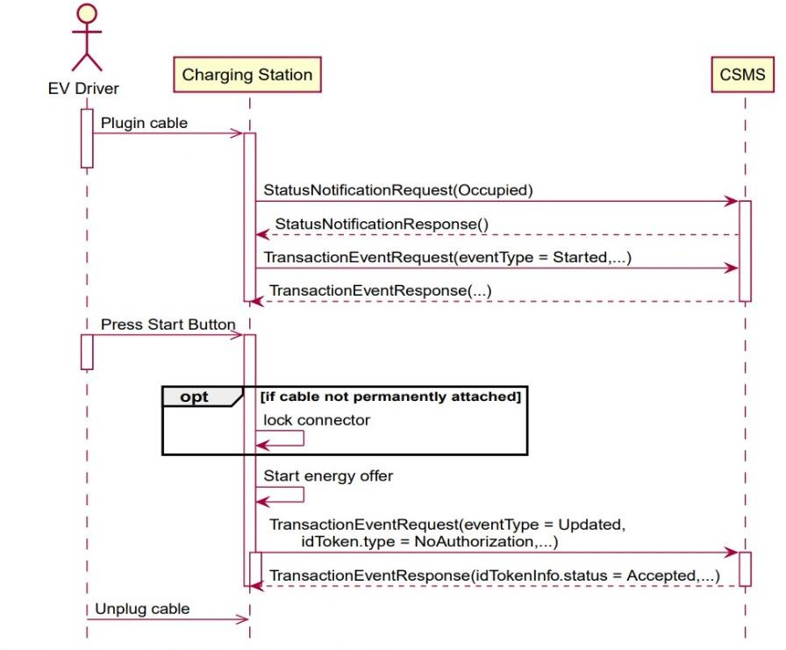

Figure ???? : Use case Diagram : Auth using start button

Enhanced Security

OCPP 1.6:
- Basic security measures include Transport Layer Security (TLS) for encrypted communication.
- Authentication is limited to username-password combinations, which can be vulnerable if not properly configured.

OCPP 2.0:
- Implements robust security profiles:
  - Security Profile 1: Basic unencrypted communication (not recommended).
  - Security Profile 2: Encrypted communication using TLS.
  - Security Profile 3: End-to-end encryption and mutual authentication using X.509 certificates.

- Introduces certificate management features for secure firmware updates and authentication, ensuring compliance with modern cybersecurity standards.

Firmware Management

OCPP 1.6:
- Supports remote firmware updates but lacks advanced monitoring and validation tools.

OCPP 2.0:
- Enhances firmware management with features like secure delivery via HTTPS and signature verification to prevent unauthorized installations.
- Includes detailed status updates through FirmwareStatusNotification, providing operators with real-time insights into the update process.

Backward Compatibility

OCPP 1.6:
- Compatible with earlier versions like OCPP 1.5, ensuring ease of transition for existing systems.

OCPP 2.0:
- Not backward compatible with OCPP 1.6 due to significant structural and functional changes. Migration requires updating both CSMS and charger firmware.

Use Cases and Scalability

OCPP 1.6:
- Suitable for smaller, less complex charging networks with basic operational needs.
- Limited support for advanced use cases like V2G or complex energy optimization.

OCPP 2.0:
- Designed for large-scale, modern EV networks with advanced requirements like fleet management, renewable energy integration, and demand response programs.
- Scalable for multi-connector EVSEs and capable of managing sophisticated energy use cases.

Technical Comparison :

Feature | OCPP 1.6 | OCPP 2.0
Release | 2015 | 2020
Adoption | Very high | Still growing
Smart charging | Static profiles | Dynamic real-time control
Security | Basic TLS | Advanced certificate-based
ISO 15118 integration | Limited | Native support
Device model | Simple | Hierarchical
Complexity | Low | High

Table ????? :
- OCPP 2.0 introduces advanced smart charging, stronger security, and better device management, but requires new hardware and major migration effort
- OCPP 1.6 remains the dominant protocol in use worldwide.
- Most charging stations and backend systems support OCPP 1.6 by default.
- OCPP 2.0 is still in early adoption stages

Why Using OCPP 1.6 in Algeria : Limited EV infrastructure in Algeria
The choice of OCPP 1.6 over OCPP 2.0 in the Algerian context is justified by several practical and technical considerations, detailed below.
- Algeria is still in early EV deployment stage
- No large smart grid integration yet
- No V2G infrastructure
- Therefore, advanced features of OCPP 2.0 are not necessary

Hardware availability
      - Most low-cost chargers available in developing markets support only OCPP 1.6
      - OCPP 2.0 chargers are more expensive and rare
  - OCPP 1.6 is economically suitable

Simplicity for academic prototype
      - OCPP 1.6 easier to implement
      - More documentation available
  - Many open-source simulators use OCPP 1.6

Network constraints (important for Algeria)
      - OCPP 1.6 works well with low bandwidth
      - OCPP 2.0 requires continuous advanced communication
  - 1.6 is better for unstable internet environments

Industry compatibility
Most deployed chargers worldwide still run OCPP 1.6, ensuring interoperability between vendors.

Conclusion
In this project, OCPP 1.6 was selected instead of OCPP 2.0 due to its widespread adoption, lower implementation complexity, and better compatibility with existing charging infrastructure. While OCPP 2.0 introduces advanced features such as enhanced security and dynamic smart charging, these functionalities are not required in the current Algerian context where EV deployment is still limited. Furthermore, OCPP 1.6 is supported by most available charging stations and offers sufficient capabilities for remote monitoring, transaction management, and basic smart charging. Therefore, OCPP 1.6 represents a practical and cost-effective choice for the proposed system.

References:
- https://www.luxmanenergy.com/ocpp-1-6-vs-ocpp-2-0-a-detailed-comparison-for-ev-chargers/?utm_source=chatgpt.com
- https://www.ampcontrol.io/post/ocpp-1-6-vs-ocpp-2-0-a-comprehensive-comparison?utm_source=chatgpt.com

